|  |  |
| --- | --- |
| Big Bang Day | On Wednesday 26th February, we will going on a trip to London Zoo. This will be an incredible experience for the children to get up close and learn about different types of animals and immerse in different walk-through habitats. |

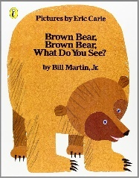

English

The children will be writing their letters to London Zoo based on our trip. They will then choose their favourite animal from the trip and create an information leaflet describing the animal’s appearance, diet and habitats.

Maths

This term the children will be extending their knowledge of place value up to 50 and continue to identify and represent numbers using objects and pictorial representations including the number line, etc. They will also be learning about length and height, mass and volume.

Science

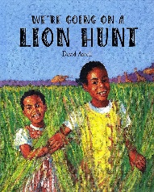

The children will be developing their knowledge of the Animal Kingdom. They will identify a variety of mammals, reptiles, amphibians, fish, birds. They will also be classifying animals and looking at their habitats and learn why animals are suited for them.

Humanities

Our focus is Geography this term. The children will be identifying seasonal and daily weather patterns in the United Kingdom. They will be looking at hot and cold areas in the world in relation to the Equator and North and South Poles, using maps to identify this. They will be looking at animals that might live in these weather conditions.

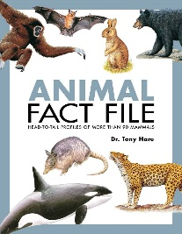

We will continue to learn and explore different places of worship, comparing the similarities and differences between: a church, synagogue and a mosque. We continue to look at the different features and artefacts and find out their meaning and significance within the religion.

The children will be learning about different styles of music through singing and playing instruments. Our song this half term is Round and Round, a Bossa Nova Latin style.

Art/D&T

Music

Our focus is Art this term. The children will explore mark making using different lines. They will learn how to add tone and gradient using shading and how this can create a 3D effect.

Religious Education

Physical Education

In Health & Relationships this term, the children will be focusing on ‘belonging to a community’, identifying and celebrating the similarities and differences within the people

The children will develop our skills on target games, building on our skills in throwing and catching. We will also build on our teamwork skills.

Personal Development

The children will identify and describe the basic elements of coding such as commands, sequence loops and events. They will apply their coding skills to create board games with characters and obstacles, and then give and receive feedback on their work.

Computing