|  |  |
| --- | --- |
| Big Bang Day | Tuesday 7th January - We will spend the day exploring different methods of transport and create our own vehicles. To do this, it would be so kind if your child can bring recyclable materials (small boxes, cardboard tubes, lolly sticks, round objects for wheels e.g. milk caps, buttons, etc.). |

This term, children will be exploring the Naughty Bus by Jan and Jerry Oke. The children will write their own journey tale about a different mode of transport focusing on exclamation marks and recapping on prior learning about adjectives.

English

The children will be extending their knowledge of numbers up to 20 using a variety of manipulatives to support their learning and understanding of place value.

Maths

Humanities

Our focus is History this term. The children will be learning all about the different types of transport and how they have changed over time. They will also be looking at chronology and be introduced to a timeline where they will be adding transport from then and now.

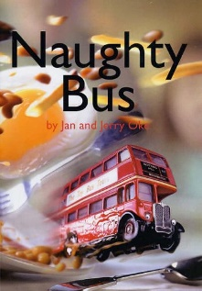

Religious Education

Physical Education

The children will build on their learning on gymnastics by exploring different pathways of travel and creating a sequence of movements.

In Health & Relationships this term, the children will be learning about who in our community looks after us.

Personal Development

Our key question is “What makes some places sacred?”. They will be able to recognise that there are special places where people go to worship and talk about what people do there. They will be able to identify at least three objects used in worship in two religions.

The children will focus on Artificial Intelligence. They will be using logical reasoning to predict the behaviour of simple programs.

Computing

The children will be learning about different styles of music through singing and playing instruments, including performing.

Music

Art/D&T

Our focus is DT this term. The children will be designing and creating their own moving toy. They will be introduced to design briefs, experiment with wheels and axles and evaluate their finished products.