|  |  |
| --- | --- |
| Big Bang Day | Tuesday 5th November 2024 - We will be making our own superhero masks and capes out of recycled materials and be exploring the topic for the term together. We will also create a collaborative piece of art. |

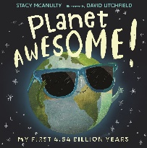

This term, we will be reading Planet Awesome, Eco-Girl and Dear Greenpeace.. Our focus for writing will be the use of capital letters, full stops, finger spaces whilst emphasising the use of phonics for spelling. We will be writing information text, letters and poems.

English

We will be continuing to learn about addition and subtraction within ten and securing their knowledge of number bonds to ten. We will be using maths manipulatives to help our learning. We will also be revisiting and expanding our knowledge of 2d and 3d shapes.

Maths

The children will focus on Everyday Materials. We will explore and describe different materials and their properties, looking at what objects are made from and develop our investigation skills through simple scientific experiments.

Science

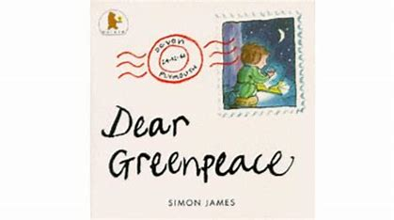

We will be focusing on our core value of Teamwork. Children will focus on how to be aware of their peers, their strengths and how working together can result in great work and ideas.

Personal Development

Physical Education

The children will be learning Dance this term. They will be using the actions and motions of animals to inspire their own moves and routines.

Our key question is “How and Why do we celebrate special and sacred times?’ – they will look at how special times are celebrated differently.

Religious Education

Children will continue to learn the features of an iPad. This will include to scan a QR code, access notes and use the microphone to dictate.

Computing

The children will be exploring rhythm and rap through the Charanga unit ‘Dance, Sing and Clap’. We will be continuing to secure the skill of finding the pulse to a song and moving in different ways to a beat and rhythms.

Music

Our focus is Art this term. The children will begin to explore where they will create their own patterns using a range of printing techniques inspired by our topic.

Art/D&T

Our focus is Geography this term. The children will be learning the names and locations of the seven continents and five oceans. We will continue to develop our knowledge on human and physical features around and link our learning to plastic pollution.

Humanities