
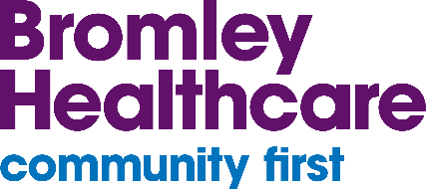
January/February 2025

Tri-borough SEND Newsletter
Bromley Healthcare provides Special Educational Needs and Disabilities (SEND) support to people living in Bromley, Bexley and Greenwich, in partnership with other key professionals and networks.
-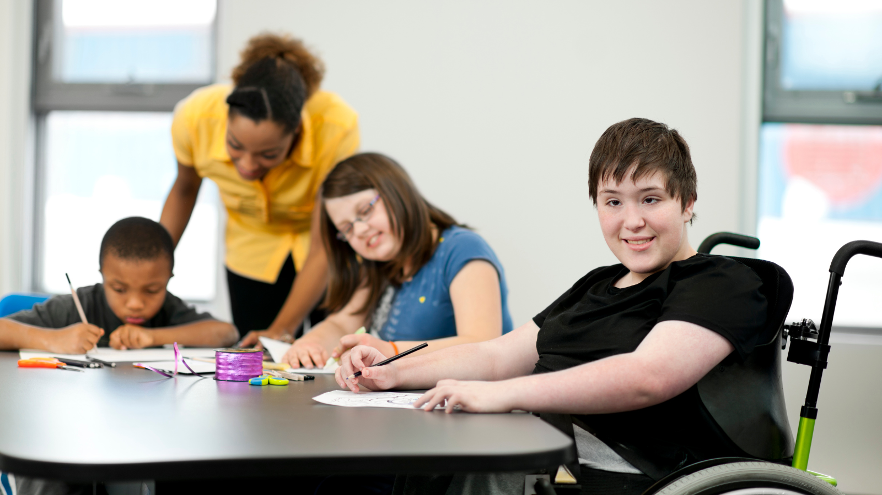
Welcome to the latest edition of the Tri-borough SEND Newsletter! We aim to publish these to you every 6 to 8 weeks.
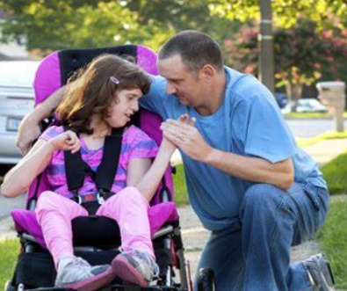    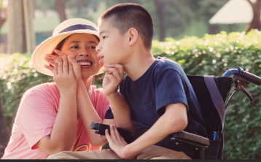 | Author’s note for parents and carers  A new year calls for new year’s resolutions! But before creating new goals, we encourage you to write down all the challenges you overcame this past year. Taking the time to reflect and pride yourself on what you have accomplished in 2024, helping you build the right mind-set for 2025.  As a parent of a child with different abilities, you may have a busy schedule with little time to focus on new goals. However, we are here to remind you that it’s important to prioritize yourself.  When it comes down to it, you are an amazing parent, and you are doing a great job. Despite the little things that may not go your way, you are your child’s hero, and they love you regardless. Remember, it is acceptable to make time for yourself. You may feel you always need to prioritise your child but prioritising yourself is bettering you as a parent. Putting time towards yourself is a new year’s resolution that will create a healthy future for both you and your child.
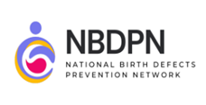 | January is National Birth Defects month  National Birth Defects Prevention Network (NBDPN) mission:  To promote healthy pregnancies and improve the health of individuals affected by birth defects through population-based birth defects surveillance, strategic collaborations, and scientific research.  National Birth Defects Prevention Network | (nbdpn.org)  While "birth defect" is a medical term, it doesn't mean that an individual is "defective." It refers to health conditions that develop in a baby before birth. In an attempt to be accurate and sensitive, it’s important to try to use the specific name of the condition present at birth when possible.
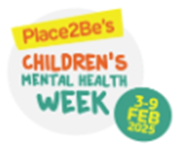 | Place2Be’s Children’s Mental Health Week: 3-9 February  Children's Mental Health Week is a mental health week launched by Place2Be to empower, equip and give a voice to all children and young people in the UK.  Find out more: Place2Be's Children's Mental Health Week - Official site (childrensmentalhealthweek.org.uk)  Parents and carers play an important role in your child’s mental health. Every year, Place2Be experts create free resources to help you support your child's wellbeing from home.  Find out more: Families - Children's Mental Health Week (childrensmentalhealthweek.org.uk)
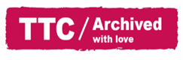 | Time to Talk day: 4 February  Time to Talk Day is taking place on Thursday 4 February. This year’s focus is on the ‘power of small’, because however you have a conversation about mental health – whether it’s a quick text to a friend, a virtual coffee morning with colleagues, or a socially distanced walk and talk with your family – it has the power to make a big difference.  Find out more: time-to-change.org.uk/time-talk-day/resources-your-event
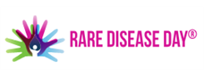 | Rare Disease day: 28 February  Rare Disease Day is the globally coordinated movement on rare diseases, working towards equity in social opportunity, healthcare, and access to diagnosis and therapies for people living with a rare disease.  Rare Disease Day is observed every year on 28 February or 29 February in leap years - the rarest day of the year.  Find out more: rarediseaseday.org

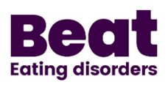 | Eating Disorder Awareness week  An international awareness event, fighting the myths and misunderstandings that surround eating disorders. 1.25 million people in the UK are living with an eating disorder right now, but behind each one is a network of loved ones struggling too.  Eating Disorders Awareness Week (EDAW) is hosted by BEAT and runs from 24 February - 2 March 2025.  Find out more: beateatingdisorders.org.uk

Useful resources
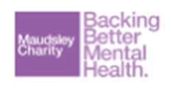 | Maudsley Charity – Families under pressure  Tips and tricks to help with challenging behaviour, formulated by researchers and NHS mental health experts, which are backed by science and proven to work with families:  maudsleycharity.org/familiesunderpressure
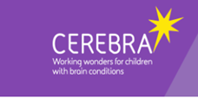 | Self-injury in children with intellectual disability  Cerebra have published a new comprehensive guide for parents on ‘Self-injury in children with intellectual disability’ in partnership with the Cerebra Network for Neurodevelopmental Disorders:  Self-injury in children with intellectual disability - Cerebra
 | What is a Hospital Passport?  It is important to get help with your health when you need it.  Find out about hospital passports, the learning disability register, reasonable adjustments and how to ask for help:  Health Guides: Hospital Passports, Summary Care Records And Flu Jabs | Mencap
 | Tri-borough Local Offers  The Local Offer is a document that gives information about the support services available in your local area. This specifically for children, young people and their families with Special Educational Needs and / or Disabilities (SEND).  Home | Bexley Local Offer  About the Bromley Local Offer | London Borough of Bromley  About the Local Offer | Royal Borough of Greenwich

Get to Know Your Local Children and Family Centres
Bexley About the Children's Centres | London Borough of Bexley
Bromley Children and Family Centres (bromley.gov.uk)
Greenwich Children's centres | Royal Borough of Greenwich
Should your you require any further support or information, please contact the Health Visiting Tri-borough SEND Specialists at:
Contact: bromh.tri-boroughsendchampions@nhs.net

Please also follow us at the following social media platforms:
Bexley 0 to 19  Bromley 0 to 19  Greenwich 0 to 4 |   @bexley_0to19  @bromley_0to19  @greenwich_0to4
We want to hear your feedback on our services. Visit careopinion.org.uk/youropinion.

