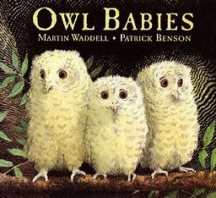

|  |  |
| --- | --- |
| Topic Overview | This topic brings together the mysterious (night) and the routine (day). Children will learn about nocturnal and diurnal animals, explore the concept of time and outer space. The turning of the day to night is a part of the rhythm of everyone’s lives, and this enables young children to understand the concept of time in relation to their own lives as well as animals. |
| Big Bang Day | Tuesday 7th January – Children dress up as a nocturnal or diurnal animal |

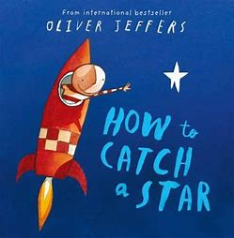

This term we will be introducing zero so that children understand how to represent 0. They will continue to develop their understanding that all numbers are made up of smaller numbers by learning number bonds to make 4 and 5. Children will explore and compare the mass and capacity of objects using mathematical vocabulary. The children will recognise, find and make 6, 7 and 8.

Mathematics

Children will link phonemes to graphemes, read simple phrases and sentences made up of words with known letter–sound correspondences and read a few common exception words. Predict and anticipate key events based on illustrations, story content and title. Understand the structure of a non-fiction book is different to a fiction book. Form most letters correctly. Segment the sounds in simple words and blend them together. Write their own name independently and other things such as labels and short captions.

labels, captions.

Phonics: Little Wandle Letters and Sounds Revised.

Revise Phase 2 letters, sounds and formations, Digraphs

ai,ee,igh,oa,oo,oo,ar,or,ur,ow,oi,ear,air,er. Words with

double letters: dd mm tt bb rr gg pp ff. Tricky words – was

you they my by all are sure pure

Literacy

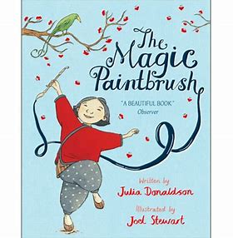

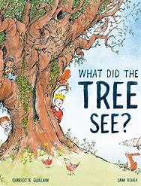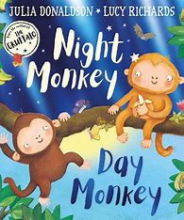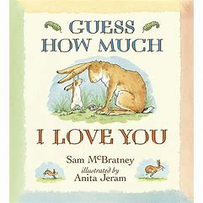

We will develop their small motor skills so that they can use a range of tools competently, safely and confidently. Suggested tools: pencils for drawing and writing, paintbrushes, scissors, knives, forks and spoons. They will have good pencil control and form recognisable letters. Use their core muscle strength to achieve a good posture when sitting at a table or sitting on the floor.

Children will celebrate Valentine’s Day, Chinese New Year, Shrove Tuesday and Ash Wednesday. They will explore collections of materials with similar and/or different properties. Talk about the differences between materials and changes they notice (i.e. ice, chocolate, jelly). Understand the effect of changing seasons on the natural world around them. Explore light and dark and create shadows.

We will develop storylines in their pretend play. Develop their own ideas and then decide which materials to use to express them. Make imaginative and complex ‘small worlds’ with blocks and construction kits, such as a city with different buildings and a park.

Children will be encouraged to listen carefully to rhymes and songs, paying attention to how they sound. Be able to express a point of view and to debate when they disagree, using words as well as actions. Articulate their ideas and thoughts in well-formed sentences. Connect one idea or action to another using a range of connectives.

Children will see themselves as a valuable individual and member of the class. They will continue to build constructive and respectful relationships. They will express their feelings and consider the feelings of others. Develop their sense of responsibility and membership of the school community.

Personal, Social & Emotional Development

Communication & Language

Understanding the World

Expressive Arts & Design

Physical Development