**Lime Wood Primary School**

**Oracy Guidance**

At Lime Wood Primary School, Oracy refers to the skill of expressing ideas and fostering understanding and interaction through spoken language. It enables students to become proficient speakers and attentive listeners, while enhancing their subject knowledge and comprehension through opportunities for speaking throughout the curriculum.

At Lime Wood we use talk guides across all year groups to support and ensure an safe and respectful environment for talk.

**EYFS Talk Tips**

**Years 1-6 Talk Tips**

There are four strands which can be utilised alongside the progression of skills and, therefore, adapted appropriately to the child/ren.

**Classroom Expectations:**

* **Talk Expectations Modelled by Adults:** Teachers and staff consistently demonstrate effective communication skills.
* **Talk Guidelines Displayed and Referred To:** Clear guidelines for speaking and listening are visible in the classroom and regularly referenced.
* **Thumb to Chest, Not Hands Up:** Students signal their readiness to speak by placing their thumb on their chest instead of raising their hand.
* **Use of Sentence Stems:** Sentence starters are provided to help students structure their responses.
* **Partner and Whole Class Discussions:** Lessons incorporate opportunities for both partner and whole class discussions to enhance learning.
* **Subject-Specific Vocabulary:** Emphasis on using and understanding vocabulary relevant to each subject area.

**Progression of skills**

|  |  |  |  |  |
| --- | --- | --- | --- | --- |
|  | **Physical** | **Linguistic** | **Cognitive** | **Social/Emotional** |
| **Reception** | * Speak clearly with appropriate volume * Look at who is talking and who you are talking to. | * Begin to speak in sentences, joining phrases with words such as “if, because, so, could, but.” * Use key vocabulary from class texts in verbal communication. | * Contributions that match what has been asked * Expanding on ideas using “why” * Answer ‘how’ & ‘why’ questions * Use ‘because’ to develop their ideas | * Reinforcing looking at someone who is speaking to you. * Reinforcing waiting for a turn – take turns to speak when feeding back to a group. |
| *Voice projection, clarity of pronunciation, and appropriate use of gestures.* | *Listen attentively in a range of situations. Listen to stories, accurately anticipating key events and respond to what they hear with relevant comments, questions or actions.* | *Follow instructions involving several ideas of actions. They answer ‘how’ and why’ questions about their experiences and in response to stories or events.* | *Express themselves effectively, showing awareness of listeners’ needs. They use past, present and future forms accurately when talking about events that have happened or are to happen in the future.* |
| **Year 1** | * Look at who is talking to you and you are talking to (transition focus). * Speak clearly and confidently in a range of contexts * Use appropriate tone of voice for context (projecting voice for large audience) * Use hand gestures to support delivery in presentational talk (pointing to something being discussed) | * Speak in sentences using joining phrases to link ideas * Using vocabulary appropriately specific to the topic in hand e.g. lighter/heavier rather than bigger and smaller * Take opportunities to try out new language, even if it is not always correctly used * Use sentence stems to link to other’s ideas in group discussion   e.g. ‘I agree with… because...’   * Use conjunctions to organise and sequence ideas e.g. firstly, secondly, finally | * Use ‘because’ to develop their ideas * Make relevant contributions that match what has been asked * Ask simple questions * Describe events that have happened to them in detail | * Listen and respond appropriately to others * Be willing to change their mind based on what they have heard * Begin to organise group discussions independently of an adult |
| *Voice projection, clarity of pronunciation, and appropriate use of gestures.* | Listen and respond appropriately to adults and peers. | Ask relevant questions to extend their understanding and knowledge. | *Articulate and justify answers, arguments, and opinions. Participate in discussions, presentations, performances, role play, improvisations, and debates.* |
| **Year 2** | * Look at who is talking to you and you are talking to. * Use body language to show active listening (nodding along, facial expressions) * Speak clearly and confidently with appropriate volume and pace.   Hand gestures when speaking become increasingly natural (such as pointing as someone  when referencing their idea.) | * Speaking in sentences using joining phrases to create longer sentences * Adapt how to speak in different situations according to the audience e.g. asking questions of a museum curator or having a conversation with a visitor to the classroom   Use sentence stems to signal when they are building or challenging others’ ideas in  group’ | * Offer reasons for their opinions * Recognise when they haven’t understood something and ask a question * Disagree with someone else’s opinion politely * Explain ideas and events in chronological order | * Start to develop an awareness of audience e.g. what might interest a certain group * Start to show awareness of others who have not spoken and invite them into the discussion   e.g. saying their name, asking them a question, turning to them   * Recite/deliver short   pre-prepared material to an audience |
|  | *Voice projection, clarity of pronunciation, and appropriate use of gestures.* | *Maintain attention and participate actively in collaborative conversations, staying on topic and initiating and responding to comments.* | *Use spoken language to develop understanding through speculating, hypothesizing, imagining, and exploring ideas.* | *Speak audibly and fluently with an increasing command of Standard English. Gain, maintain, and monitor the interest of the listener(s).* |

|  |  |  |  |  |
| --- | --- | --- | --- | --- |
| **Year 3** | * Deliberately selects gestures that support the delivery of ideas e.g. gesturing towards someone if referencing their ideas. * Deliberately varies tone of voice in order to convey meaning e.g. speaking authoritatively during an expert talk * Use of position and posture when addressing an audience * Use movement when addressing an audience | * Be able to use specialist language to describe their own and others’ talk * Use specialist vocabulary e.g. speak like an archaeologist * Make precise language choices   e.g. instead of describing a cake as ‘nice’ using ‘delectable’ | * Ask questions to find out more about a subject * Build on others’ ideas in discussions * Make connections between what has been said and their own and others’ experiences * Offer opinions that aren’t their own e.g. taking on a specific role in group work * Begin to reflect on discussions and their own oracy skills and identify areas of strength and areas to improve through the introduction of Talk Detectives | * Speak with confidence in front of an audience * Begin to recognise different roles within group talk e.g. chairperson * Adapt the content of their speech for a specific audience |
| *Voice projection, clarity of pronunciation, and appropriate use of gestures.* | *Listen and respond appropriately to adults and their peers.* | *Ask relevant questions to extend their understanding and knowledge.* | *Use spoken language to develop understanding through speculating, hypothesizing, imagining, and exploring ideas. Participate in discussions, presentations, performances, role play, improvisations, and debates.* |
| **Year 4** | * Deliberately select movement and gesture when addressing an audience * Use pauses for effect in presentational talk. * Use the appropriate tone of voice in the right context e.g. speaking calmly when resolving an issue in the playground | * Carefully consider the words and phrasing they use to express their ideas and how this supports the purpose of the talk e.g. to persuade or to entertain | * Reach shared agreement in discussions * Give supporting evidence e.g. citing a text (using sentence stems) a previous example or a historical event   + Ask probing questions   + Reflect on their own oracy skills and identify areas of strength and areas to improve and begin to set own targets. | * Use more natural and subtle prompts for turn taking * Start to develop empathy with an audience * Consider the impact of their words on others when giving feedback |
| *Voice projection, clarity of pronunciation, and appropriate use of gestures.* | *Maintain attention and participate actively in collaborative conversations, staying on topic and initiating and responding to comments.* | *Consider and evaluate different viewpoints, attending to and building on the contributions of others.* | *Articulate and justify answers, arguments, and opinions. Use spoken language to develop understanding through speculating, hypothesizing, imagining, and exploring ideas.* |
| **Year 5** | * Deliberately varies tone of voice in order to convey meaning e.g. speaking authoritatively during an expert talk, or speaking with pathos when telling a sad part of a story * Project their voice to a large audience * Gestures become increasingly natural * Consciously adapt tone, pace and volume of voice within a single context. | * Use an increasingly sophisticated range of sentence stems with fluency and accuracy to cite evidence and ask probing questions * Consider the words and phrases used to express their ideas and how this supports the purpose of talk | * Draw upon knowledge of the world to support their own point of view and explore different perspectives * To be able to give supporting evidence e.g. citing a text, a previous example or a historical event   Identify when a discussion is going off topic and be able to bring it back on track with support and use of sentence stems e.g. That might be true, however what do you think about …? | * Listen for extended periods of time including notetaking, drawing visual * Adapt the content of their speech for a specific audience   e.g. use of humour   * Speak with flair and passion |
| *Voice projection, clarity of pronunciation, and appropriate use of gestures.* | *Listen and respond appropriately to adults and their peers.* | *Ask relevant questions to extend their understanding and knowledge.* | *Articulate and justify answers, arguments, and opinions. Participate in discussions, presentations, performances, role play, improvisations, and debates.* |

|  |  |  |  |  |
| --- | --- | --- | --- | --- |
| **Year 6** | * Speak fluently in front of an audience. * Have a stage presence * Consciously adapt, tone, pace and volume of voice | * Use and innovate an increasingly sophisticated range of sentence stems with fluency and accuracy * Vary sentence structures and length for effect when speaking | * Construct a detailed argument or complex narrative * Spontaneously respond to and offer increasingly complex questions, citing evidence where appropriate * Reflect on their own and others’ oracy skills and identify how to improve. | * Use humour effectively * Begin to be able to read a room or a group and take action accordingly e.g. if everyone looks disengaged, moving on or changing topic, or if people look confused stopping to take questions |
| *Voice projection, clarity of pronunciation, and appropriate use of gestures.* | *Maintain attention and participate actively in collaborative conversations, staying on topic and initiating and responding to comments.* | *Consider and evaluate different viewpoints, attending to and building on the contributions of others.* | *Articulate and justify answers, arguments, and opinions. Use spoken language to develop understanding through speculating, hypothesizing, imagining, and exploring ideas.* |

**Learning Opportunities linked to key skills progression:**

|  |  |  |  |  |
| --- | --- | --- | --- | --- |
|  | **Physical** | **Linguistic** | **Cognitive** | **Social/Emotional** |
| **Reception** | **Activity:** Storytime with actions.  **Example:** Children listen to a story and act out parts using gestures and facial expressions | **Activity:** Vocabulary games.  **Example:** Playing “I Spy” to identify objects and describe them | **Activity:** Question and answer sessions.  **Example:** Asking children to predict what happens next in a story. | **Activity:** Circle time discussions.  **Example:** Sharing feelings about their day and listening to others |
| **Year 1** | **Activity:** Show and tell.  **Example:** Children bring an item from home and describe it to the class, focusing on clear speech and posture. | **Activity:** Rhyming games.  **Example:** Creating rhyming pairs and simple poems. | **Activity:** Story sequencing.  **Example:** Retelling a story in the correct order using picture cards. | **Activity:** Partner discussions.  **Example:** Discussing a favorite activity with a partner and then sharing with the class. |
| **Year 2** | **Activity:** Role play.  **Example:** Acting out scenes from a story or historical event. | **Activity:** Word webs.  **Example:** Creating webs of related words to expand vocabulary. | **Activity:** Problem-solving discussions.  **Example:** Discussing how to solve a simple problem, like building a tower with blocks. | **Activity:** Group projects.  **Example:** Working in small groups to create a poster about a topic. |
| **Year 3** | **Activity:** Drama activities.  **Example:** Performing short plays or skits. | **Activity:** Descriptive writing.  **Example:** Writing and sharing descriptions of a favorite place. | **Activity:** Debates.  **Example:** Debating simple topics like “Is it better to have a pet cat or dog?” | **Activity:** Peer feedback.  **Example:** Giving and receiving constructive feedback on presentations. |
| **Year 4** | **Activity:** Public speaking practice.  **Example:** Giving a short speech on a chosen topic. | **Activity:** Synonym and antonym games.  **Example:** Finding synonyms and antonyms for common words. | **Activity:** Critical thinking exercises.  **Example:** Discussing the pros and cons of a new school rule. | **Activity:** Empathy exercises.  **Example:** Role-playing different scenarios to understand others’ perspectives. |
| **Year 5** | **Activity:** Formal presentations.  **Example:** Presenting a project to the class with visual aids. | **Activity:** Advanced vocabulary building.  **Example:** Learning and using new words in context. | **Activity:** Analytical discussions.  **Example:** Analyzing characters’ motivations in a story. | **Activity:** Group discussions.  **Example:** Discussing current events and their impact on the community. |
| **Year 6** | **Activity:** Debating competitions.  **Example:** Participating in structured debates on various topics. | **Activity:** Persuasive writing and speaking.  **Example:** Writing and delivering persuasive speeches. | **Activity:** Research projects.  **Example:** Researching a topic and presenting findings to the class. | **Activity:** Leadership roles.  **Example:** Leading group activities and discussions. |

We encourage lessons to include opportunities for partner and group discussions with teachers skillfully targeting questions and assessment for learning tools so that every child’s voice is heard and encouraged as well as valued. Subject-specific terminology is included in lesson plans and displayed in classrooms so that children can reference these in their learning.

As our Oracy journey continues; our curriculum plans will include noted specific opportunities for talk as part of each topic in the form of: group discussions, debates, presentations.

Our school values are also integral to our Oracy journey:

**Respect** – Equality, Tolerance, Understanding

**Pride** – Ambition and achievement

**Kindness** – Caring, Sharing and Listening

**Teamwork** – Cooperation and collaboration

**Curiosity** – Resilience, creativity and determination

Children will be able to effectively communicate their understanding, enabling them to work cooperatively with their peers and will become independent learners and take responsibility for their learning. They will develop resilience when dealing with challenging concepts, which can be applied to other aspects of life.

Children will be able to express issues and ideas, speak clearly, listen carefully, contribute to discussion, respond to questions and comments and use a wide and interesting vocabulary.

**Early Years**

At Lime Wood Primary, we follow the ShREC approach to ensure there are high quality interactions with children throughout our provision.

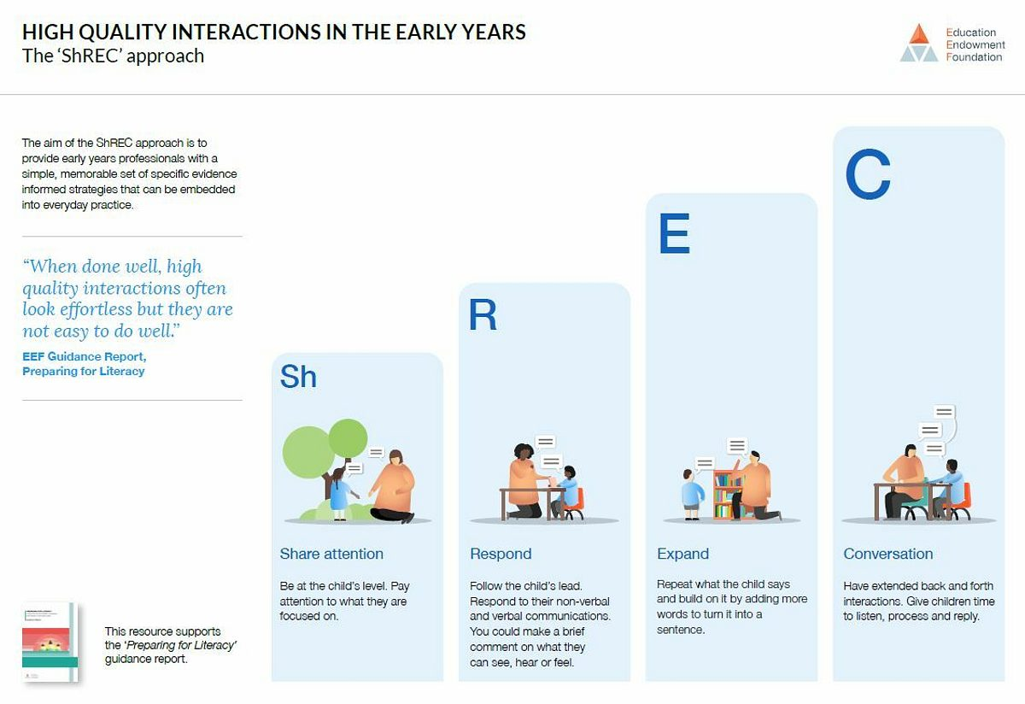

**Teaching Walkthrus**

At Lime Wood Primary School, we utilise Teaching Walkthrus to develop our pedagogy, teaching and learning. There are a number of strategies that we employ across the school and these will be developed further as we continue our Oracy journey.

